Steps of MapReduce Practical
Step 1: Double click on eclipse in Cloudera manager screen as shown below.

Step2: Click on File→New→ Java Project
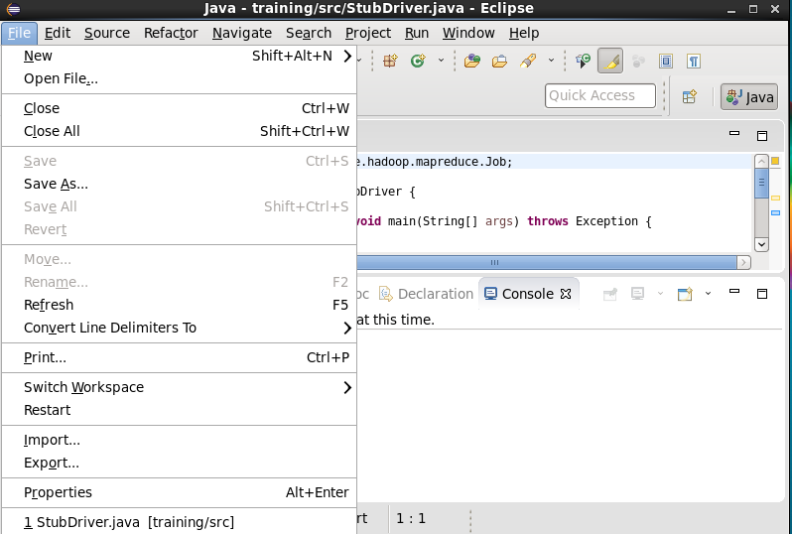

Step3: Give project Name WordCount and click Next.
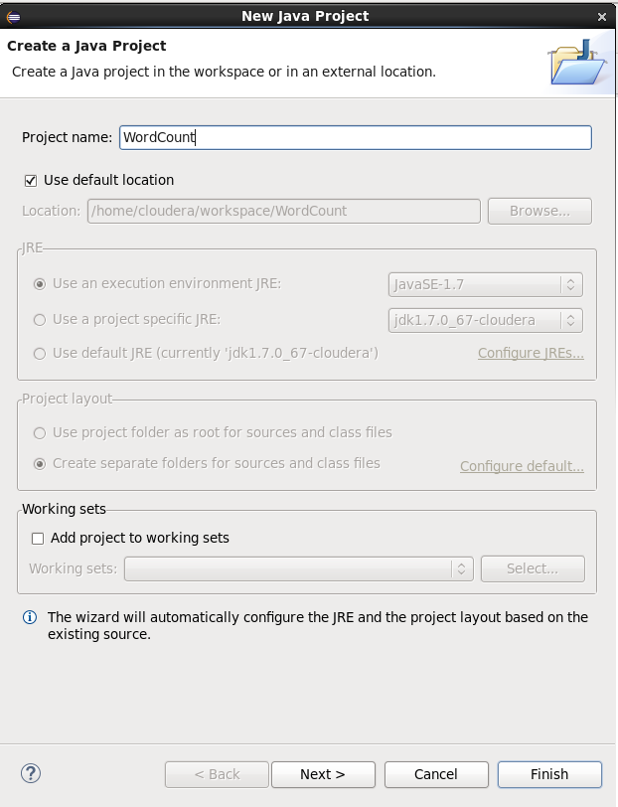
Step 4: The screen below will show up after selecting Next in step 3, don’t click Next after that. Select the Libraries Tab. Next, select "Add External Jars”.
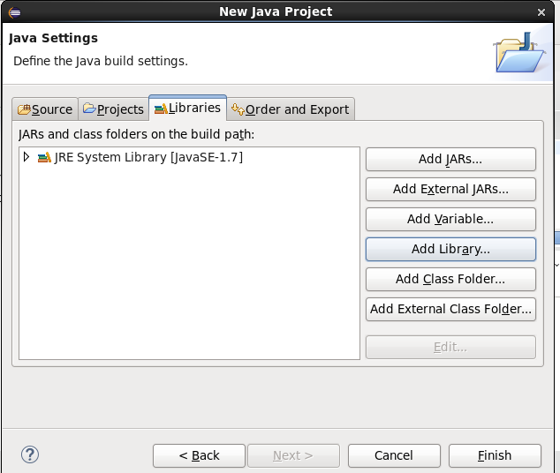
Step 5:- Click on File System→ usr→lib→Hadoop then select all Jar files(yellow) and click OK.
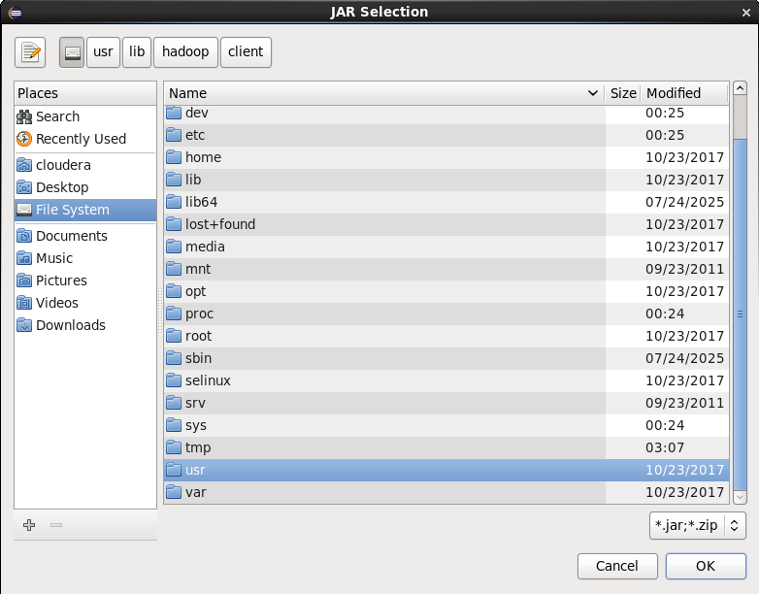
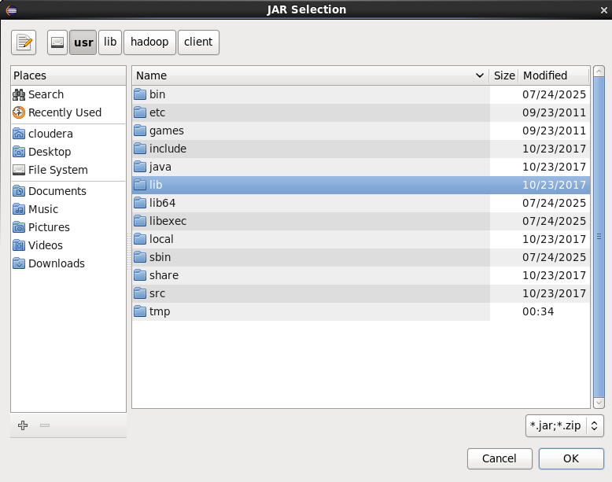
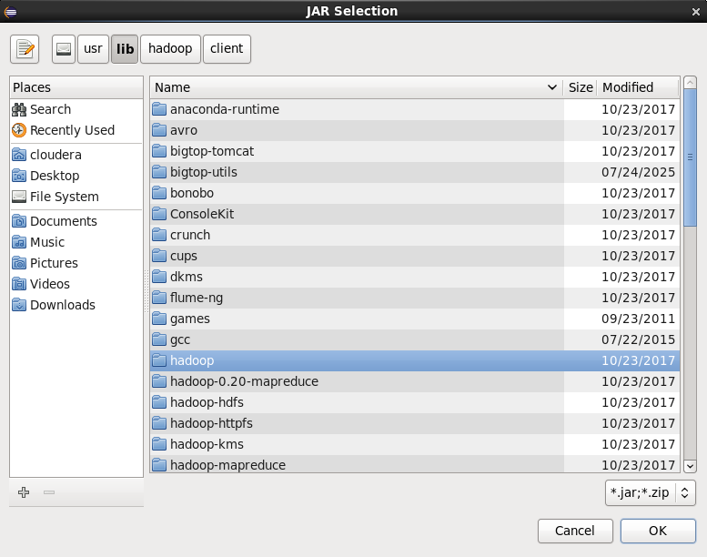

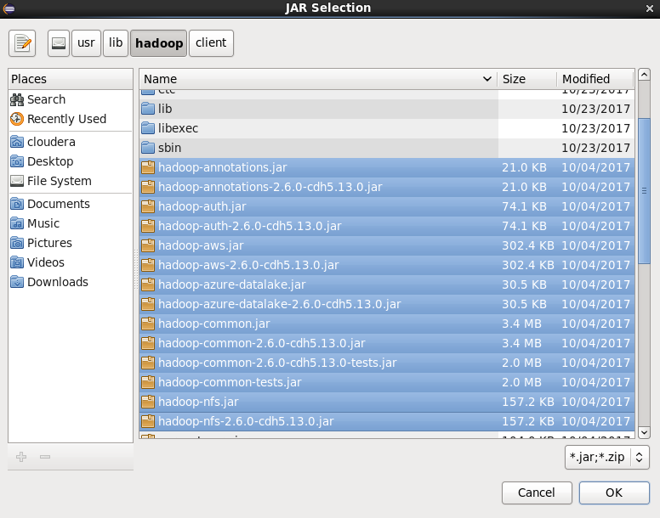

Step 6: Click again on Add External Jar then click on client. Select All Jar files and click on finish.
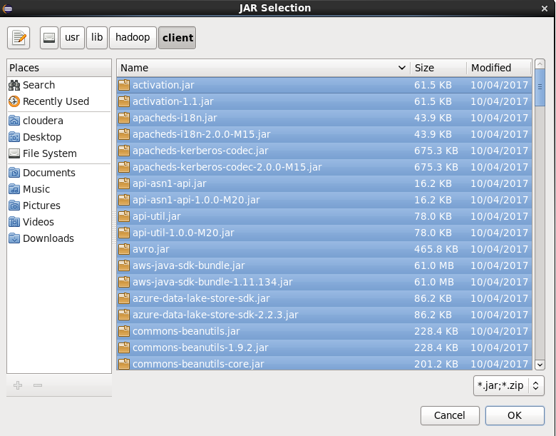
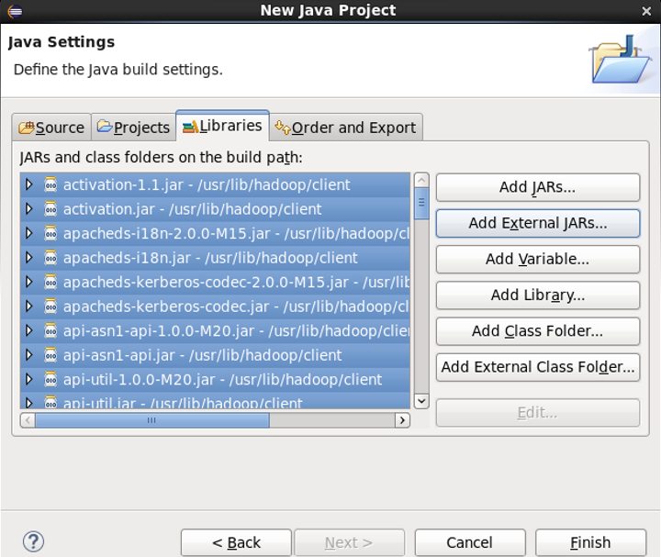
Step 7: Click on WordCount→New→Class
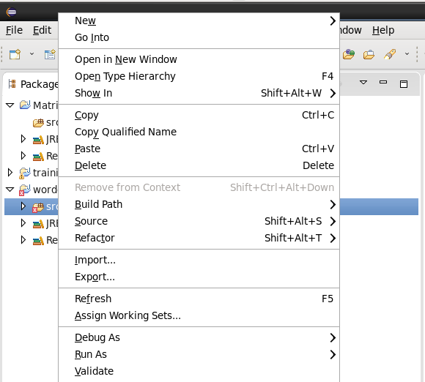

Step 8: Give the name as wordcount. Then click on finish.
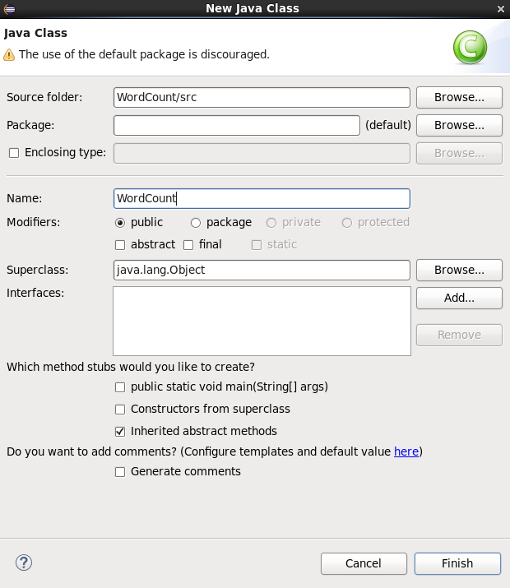

Step 9: Write the code of WordCount program in right pane.
